Who is Charles Lindbergh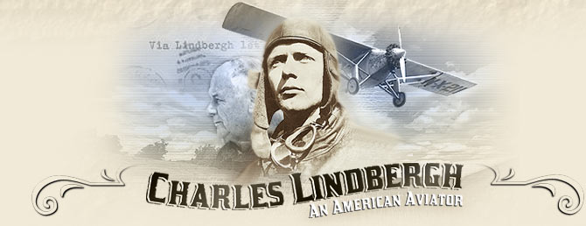

Charles Lindbergh was an American Aviator and was the first person to fly over the Atlantic Ocean solo. He was born on February 4th, 1902 in Detroit, Michigan. He was a father, husband and an american hero. Charles’s full name was Charles Augustus Lindbergh. He died on August 26th, 1974 in Kipahulu, Maui in Hawaii a the age of 72. Charles died due to Lymphoma which is a type of blood cancer. His resting place is in Palapala Ho'omau Church cemetery.

Education

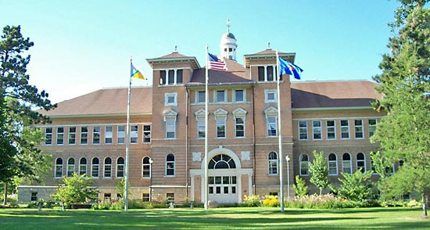

Charles went to Sidwell Friends school which has pre-K through 12th grade. Some of his classmates were Quentin and Kermit Roosevelt, sons of a former president.For High School he went to Redondo Union High School and Little Falls High School. His grades went down after going to Little Falls High School. Later he went to the University of Wisconsin, but left after the second year. He enrolled in flight school in Nebraska in April 1922. After that he was accepted into the U.S. Army Flight School.

What else did he do?

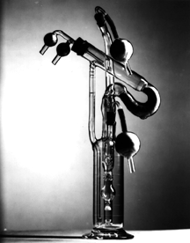

Charles Lindbergh was many things. Early on he was a Barnstormer which was a daredevil pilot. He fought in World War 2. While in WW2, he taught pilots how to fly better. He was an author. For example he wrote the book, Spirit of St. Louis. He was also an inventor and invented an artificial heart. In addition, he was an explorer and liked to fly in uncharted territory. Later on, he fought for the conservation of nature and wild life.

Involvement in World War 2

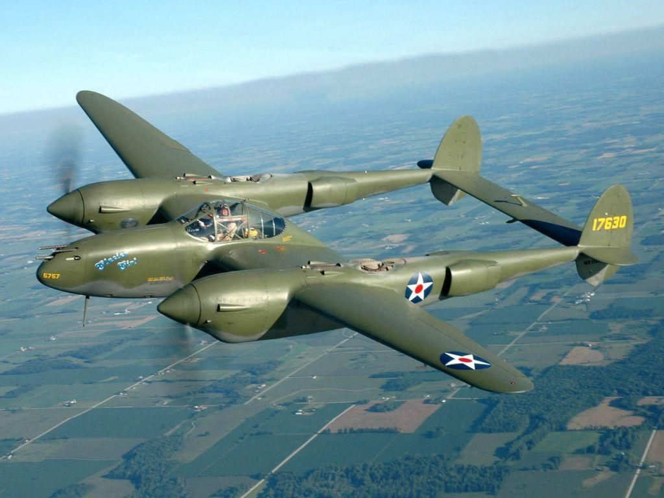

Early on, Charles Lindbergh was the number one person that thought America shouldn’t have been in the war. After the war, in his perspective, he thought America lost the war. Later on during the war, Charles acted as an advisor to the U.S. Army and Navy. He also went on to fly 50 combat missions as a civilian. He flew with the 475 Fighter Group known as Satan’s Angels. During this time, Charles flew P-38 Lightnings. He showed other pilots how to fly better such as taking off with heavier bomb payloads. After the war, he toured the Nazi concentration camps and wrote in his autobiography that he was disgusted and angered.

Flying as an Airmail Pilot

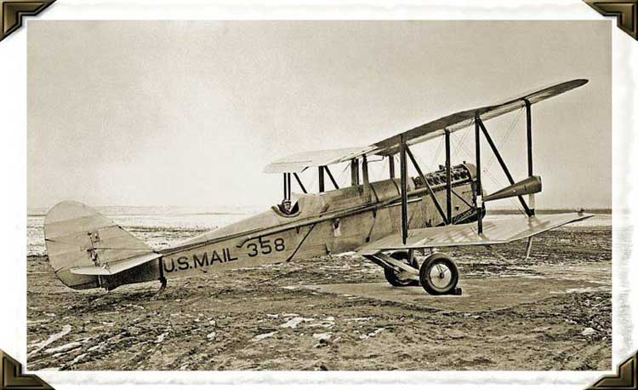

Charles joined the Nebraska Aircraft Corporation in 1922 to learn how to fly. in 1923, he enlisted in the Army and went to flight school He was the highest ranked cadet out of 104 cadets. The Army didn’t recruit pilots after graduation, so he applied for Contract Air Mail Route No. 2. He obtained a 99% air mail delivery efficiency even though he had improper equipment. Charles felt that the planes used for delivering mail were unreliable. During this time he flew a Havilland DH-4 biplance. Till February 1927, he flew as the chief pilot on his route.

Family Life

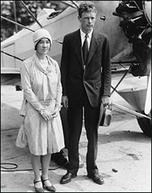

Charles Lindbergh married Anne Morrow on May 27th, 1929. Anne was also Charles’s flying partner. She was also an author and an aviator. They had 6 children: Charles Jr, Jon, Land, Anne, Scott and Reeve. After Charles Jr was kidnapped and murdered, they moved to Europe to hide from the public.

Contribution to Flight

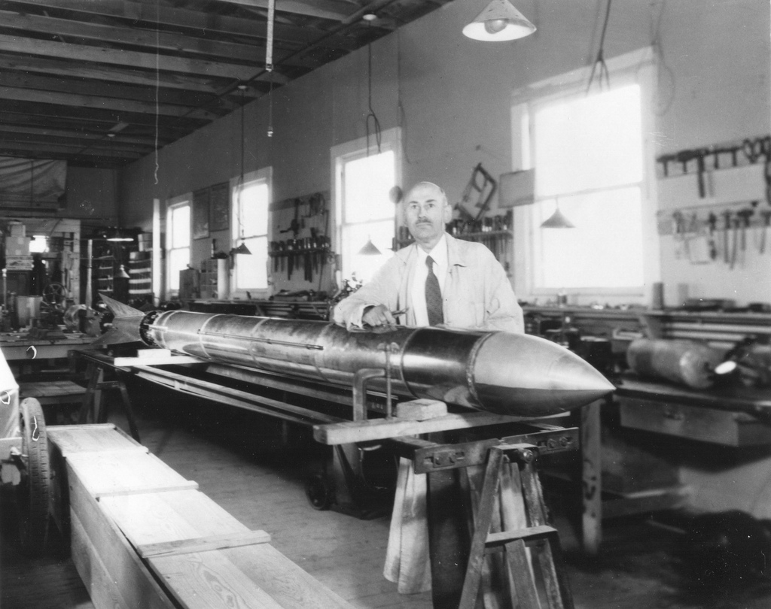

Charles Lindbergh helped prove that airplanes could cross continents and oceans. He helped people think that not just the military and government could help the aviation industry. Everyone in the world wanted to fly, creating more demand for airplanes. Because of Charles Lindbergh’s flight, Wall Street investors started investing in the aviation industry. Later, he became a consultant for aviation companies such as TWA and Pan America and explored and created new air routes. Airmail also became more popular due to Charles Lindbergh. Finally, Charles helped fund Robert Goddard, the father of modern rockets.

Early Flight

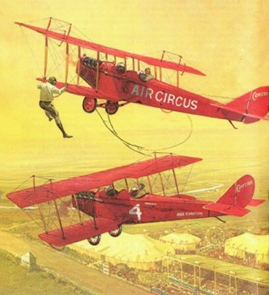

Charles Lindbergh took his very first plane ride on Sunday April 9th, 1922. Ever since he saw race cars when he was 10, he wanted to do daring stuff. He read about fighter pilots and liked working on machines like his dad’s car. Charles went to become a Barnstormer. A barnstormer is a person who gets paid to do cool tricks on a barn stage. Later, Charles got an took an offering to join the U.S. Army flying school. He graduated in 1929 as a Second Lieutenant. During peace time, their was no need for Army pilots so he joined the US Airmail Service for the U.S. Government.

What Made Him Famous?

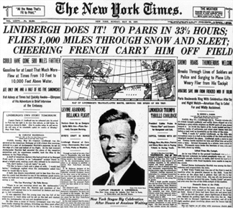

Charles was the first person ever to fly across the Atlantic Ocean on an airplane solo and nonstop. He went from New York to Paris on May 20-21, 1927. He was only 25 years old. He became of one of the first celebrities. After WWII, he went on a 3 month flying tour with his plane, the Spirit of St. Louise. He flew to 49 states, 92 cities and gave 147 speeches. Charles had his first child on May 27th, 1929. On March 1932, his son was kidnapped and 72 days later, his body was found in a patch of woods in the same neighborhood. This was called the “Crime of the Century”. A few months later, a law was passed called the Lindbergh Law which gave Federal Agents authority to chase kidnappers over state lines.

The Spirit of St. Louis.

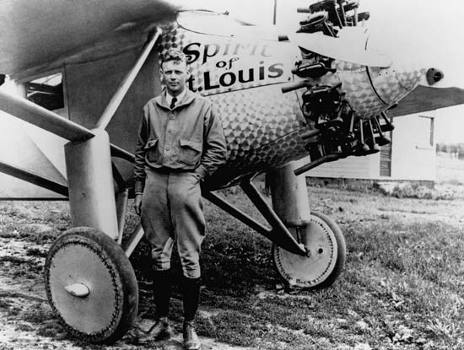

The Spirit of St. Louis was the plane Charles Lindbergh flew across the Atlantic. It was officially known as the Ryan NYP (New York to Paris) and based on the 1926 Ryan-M2 mail plane. It was named in honor of Lindbergh’s supporters from the St. Louis Racquet Club. It was registered as N-X-211 and was designed and built in 60 days. The cost of the plane in 1927 was $10580. If it were built today, the plane would have cost over $100000 to make. It used a single engine design for improved range and reliability. The fuel tanks were put in front of the him to improve the center of gravity.